**Getting started with Statistics**

Assignment 2.1

Q1: If I find Covariance between same variable what will be the output? What will be correlation coefficient?

A1: Let’s assume the variable to be 1. According to the Covariance formula:

COV (1,1) = $\sum_{i=1}^{1}{(1-1}$) / 1

= 0

COR (1,1) = 1 / 1

= 1

Q2: Assume I have a set of numbers. The mean, median and mode of the set of numbers are equal. If I draw a Frequency plot of individual distinct numbers, how would the plot look like?

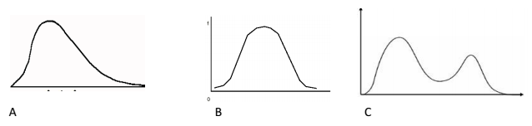

A2: The plot will look like ‘B’ since the mean, median & mode are same.